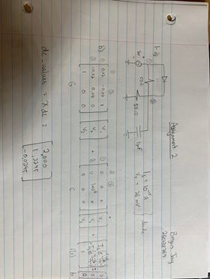**Assignment 2**

**1 – a)**

**b)** dc values = Xdc = $\left[\begin{matrix}2.0000 \\ 1.2245 \\ -0.0245\end{matrix}\right]$

**c) Iteration Number vs Normal of delta x**

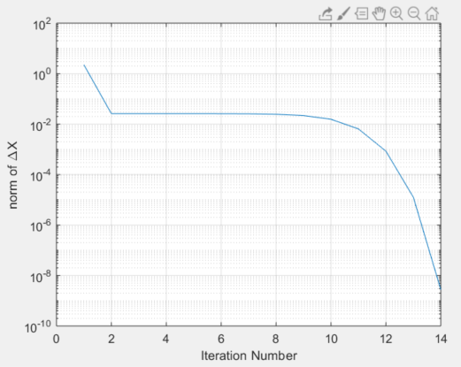

**d) MATLAB Code:**

**nlJacobian.m Function:**

function J = nlJacobian(X)

% Compute the jacobian of the nonlinear vector of the MNA equations as a

% function of X

% input: X is the current value of the unknown vector.

% output: J is the jacobian of the nonlinear vector f(X) in the MNA

% equations. The size of J should be the same as the size of G.

global G DIODE_LIST

N = size(G);

f_d = zeros(N); % Initialize the f_d (derrivative) vector (same size as G)

NbDiodes = size(DIODE_LIST,2);

% perform similar actions to the f_vector function

for I = 1:NbDiodes

% fill the 3x3 matrix

if (DIODE_LIST(I).node1 ~= 0) && (DIODE_LIST(I).node2 ~= 0)

v1 = X(DIODE_LIST(I).node1); %nodal voltage at anode

v2 = X(DIODE_LIST(I).node2); %nodal voltage at cathode

Vt = DIODE_LIST(I).Vt; % Vt of diode (part of diode model)

Is = DIODE_LIST(I).Is; % Is of Diode (part of diode model)

% calculate the matrix based on having a diode with two nodes

f_d = f_d + [ (Is/Vt)*exp((v1-v2)/Vt) (-1*Is/Vt)*exp((v1-v2)/Vt) 0 ; (-1*Is/Vt)*exp((v1-v2)/Vt) (Is/Vt)*exp((v1-v2)/Vt) 0 ; 0 0 0 ];

elseif (DIODE_LIST(I).node1 == 0)

v2 = X(DIODE_LIST(I).node2); %nodal voltage at cathode

Vt = DIODE_LIST(I).Vt; % Vt of diode (part of diode model)

Is = DIODE_LIST(I).Is; % Is of Diode (part of diode model)

f_d = f_d + [ 0 0 0 ; 0 (Is/Vt)*exp(-1*v2/Vt) 0 ; 0 0 0 ];

elseif (DIODE_LIST(I).node2 == 0)

v1 = X(DIODE_LIST(I).node1); %nodal voltage at anode

Vt = DIODE_LIST(I).Vt; % Vt of diode (part of diode model)

Is = DIODE_LIST(I).Is; % Is of Diode (part of diode model)

% one node is connected to ground

f_d = f_d + [ (Is/Vt)*exp(v1/Vt) 0 0 ; 0 0 0 ; 0 0 0 ];

end

end

% return the Jacobian

J = G + f_d;

**dcsolve.m code:**

function [Xdc, dX] = dcsolve(Xguess,maxerr)

% Compute dc solution using newtwon iteration

% input: Xguess is the initial guess for the unknown vector.

% It should be the correct size of the unknown vector.

% maxerr is the maximum allowed error. Set your code to exit the

% newton iteration once the norm of DeltaX is less than maxerr

% Output: Xdc is the correction solution

% dX is a vector containing the 2 norm of DeltaX used in the

% newton Iteration. the size of dX should be the same as the number

% of Newton-Raphson iterations. See the help on the function 'norm'

% in matlab.

global G C b

delta_x = intmax;

x_test = Xguess;

dX = [];

% since in DC this point is always 0

x_test_d = [0 ; 0 ; 0 ];

% continue iterating through until the threshold of maxerr is hit

while delta_x >= maxerr

f = f_vector(x_test);

phi = G*x_test + C*x_test_d + f - b;

% Get the Jacobian matrix

J = nlJacobian(x_test);

% get delta_x matrix

delta_x_m = -1 * inv(J) * phi;

% caclulate the new point to test and get the normal of delta_x

x_test = x_test + delta_x_m;

delta_x = norm(delta_x_m);

dX = [ dX , delta_x ];

end

Xdc = x_test;